Serve



*“Whatever you do, work at it with all your heart, as working for the Lord and not for men”*

*Colossians 3:23*

|  |  |  |  |  |  |  |
| --- | --- | --- | --- | --- | --- | --- |
| Ushers on Duty | Teller | PA System | Nursery | Children’s Church | Sunday School Facilitator | Sunday School  Café Crew |
| **December 2021** | | | | | | |
| Allison Bull & Danny McCracken | Linda Baier | Dr. Mauricio Hernández | Marina Hernández | Melinda Hernández | *Paused for Christmas Break* | *Suspended due to COVID* |

We would love for you to join us in service! For more information about serving, please contact the church office by phone or email.





Winter Storm Cancellation Procedure

In the event of inclement weather, the Board of Management determines if road conditions are sufficiently safe to allow the church to open. If service must be cancelled, our voicemail will be updated stating the cancellation and emails sent out to our Bulletin Distribution list by **9:00am**. Please call the church office (455-9495) and listen to the cancelling announcement. Also please check your emails prior to heading out to reduce the risk of travel.

If a Sunday Service is cancelled due to the weather, the plan is to upload to YouTube a modified Church Service with an email notification sent out.



Skyline Acres Baptist Church

135 Canterbury Drive, Fredericton, NB E3B 4L7 (506) 455-9495

Email us at: [skyline@nb.aibn.com](mailto:skyline@nb.aibn.com)

www.skylinebaptistnb.ca

Past, current and upcoming events on  United States YouTube Logo - Youtube Play Button Transparent Png ...

May the Lord bless and keep you safe and healthy.

*Hope to see you next week!*

Skyline Acres Baptist Church



Herein is

Love,

not that we loved God, but that

He loved us.

1 John 4:10





Christmas Eve Service

Worship Service

Christmas Blessings!

December 24, 2021 ~ 6:30 Pm

Order of Service



**Skyline Acres Baptist Church**

**December 24, 2021 - 6:30 pm**

**~Christmas Eve~**

|  |  |  |
| --- | --- | --- |
| **Prelude** | *Lori McClary* | |
|  | | |
| **Welcome** |  | |
|  | | |
| **Call to Worship** | Isaiah 7:14 | |
|  | | |
| **Opening Hymn** | *“O Come All Ye Faithful”* | |
|  | | |
| **Opening Prayer** |  | |
|  | | |
| **Special Music** | *"Away in a Manger (Sleep On)" – Lori & Bruce McClary* | |
|  | | |
| **Advent Wreath – The Christ Candle** | | *Geoffrey Stuckless* |
|  | | |
| **Special Music** | *“Mary Did You Know”? – Katherine McCoy* | |
|  |  | |
|  | | Angels / Gloria – Christmas Video |
|  | | |
| **Scripture** | Luke 2:1-20 | |
| *“* | | |
| **Sermon Title** | “Setting the Saviour’s Scene ” | |
|  | | |
| **Closing Hymn** | *“Silent Night”* | |
|  | | |
| **Benediction** |  | |
| **Postlude** | *Lori McClary* | |
| *Merry Christmas!*  *May this season be merry and bright with all the meaning packed in*  *🕊The Christmas Story 🕊* | | |
| **Meditational Verses**  10 “*Be* kindly affectionate to one another with brotherly love, in honour giving preference to one another;”  **Romans 12:10 (NKJV)** | | |

Sermon Journal



|  |  |
| --- | --- |
| Date: | December 24, 2021 |
| Sermon: | The Greatest story Ever told |
| Scripture Reading: | Luke 2:1-20 |
| Message Focus: | Bethlehem’s Manger – Mystery & Majesty  for the record - Angels’ proclamation  Shepherds’ Proclamation |
| Highlights: | What message does dr. Luke convey? |
| Life Application: | How did the Shepherds react and respond?  How do we respond? |
| Further Reflection: | Christmas has levels of meaning for our generation.  What do you enjoy about Christmas?  Celebrate God’s promises all year through! |
|  |  |

Prayer Journal



Praise Items

* Birthday of Jesus Christ our Saviour, Lord and King.
* PTL - Kim Sharpe –Secured employment
* PTL - Pastor MJ – Recovering
* PTL - Norma Reeves – DECH - Healing Coming along
* Jade Tripp – awake and responsive
* Hiltz Family (Baby Ellie) – New baby on the way!
* Marilyn Kierstead – Had Cancer Surgery on Dec 9th
* Mary McClary (Bruce’s Mom) – Recovered from Surgery

Concerns

* Beckie Crousse – 6th Round of Chemo – Getting There
* Pandemic – Covid-19 variants – Let’s pray for their eradication
* Marg Dine – Chemo Treatment & Side effects
* Don Hughes – Waiting for Heart Surgery
* Shirley (Linda’s Aunt) – diagnosed with stage 4 stomach cancer
* Family distress (Katherine’s friend) – Addiction, mental health
* R and B (Lori’s friends) – battling addiction
* Molly Demma (Marian’s friend) – Stage 2 Breast Cancer
* Shaun & Rebecca (Linda’s Friends) – Battling Cancer
* Lorraine Holland (Caroline Cusack’s niece)
* Ruth Kennedy – Women suffering in Tigray
* Christian families face “social boycott” in India
* Burmese Army attacks churches

Upcoming Birthdays!Let us celebrate another birthday year with prayer for our fellow brothers and sisters!

|  |  |
| --- | --- |
| December 29 | David Murrell |
| December 30 | Allen Crousse |
|  |  |

Announcements



Skyline Radio 107.9

Skyline Acres Church Sunday Service can now be heard on your car radio! Thanks to our P.A. Crew, we now are able to broadcast over Skyline FM Radio at 107.9 FM. The broadcast range of the radio transmission is limited to our parking lot, so if you are hesitant to attend our inside gatherings, this is the perfect choice for you! Sit in your car and listen to the songs, prayer and sermon. Come “join” us for our Christmas service and “dial” into God’s Word.

Call us at 455-9495 if you need more information.

Winter Coat Drive

 As mentioned last week, Skyline is holding a Winter Coat Drive on January 8th, 2022, to share the warmth with our community during the cold winter months. Starting this Sunday, (December 19th), bring your winter coats, jackets any winter attire to help us build a stock. Adults, Teenagers and Childrens gear – all sizes are welcomed. Drop them off at the church in the lobby at your convenience.

Our Daily Bread

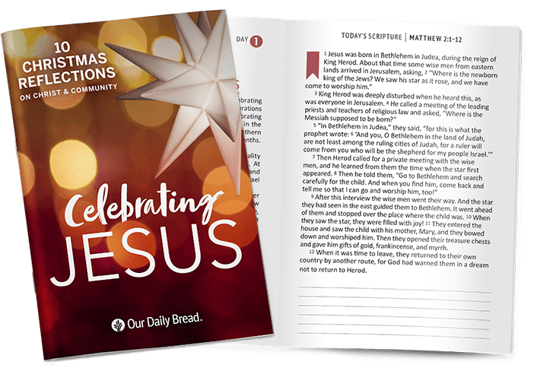Our Large-Print January-March 2022 Daily Bread Devotionals are in! These booklets with daily devotionals are packed with great insights into God’s Word and helps us to stay focused on our Saviour and His wisdom and Commandments.

All devotionals, both small, large and Christmas booklets are available on the back table, please help yourselves and share them with your friends.

Christmas Hampers

 Delivery is all done for the Christmas Hampers! Thank you for donating so generously. To the many volunteers,we say, we couldn’t have done it without you. Thank you to all for helping us show, share and spread God’s love! Special thanks to Caroline Cusack, our chairperson.

Weekly Ministries



Annual Reports

It’s that time of year again! All Chairpersons are asked to submit their Annual Reports to the office by email no later than Friday, December 31st, 2021.

Sunday Sentences for 2021

Congratulations! All year, we’ve encouraged you to write or type out the weekly Scripture References. God’s Word truly is “food” for your soul. “Vitamins” for your Faith. Feeling healthy? No doubt. Here are December’s Scripture sentences that carry the theme of “God’s Kindness.”

* December 19 – Romans 12:10
* December 24 – 1 Peter 1:5-7
* December 26 – Psalm 65.11

Covid-19 Awareness – “**Level 1**- Emergency Stage”

As we continue to worship, pray and study our Bibles together, please review the procedures which are already in place to ensure congregational safety. Ushers are available to direct and assist you as you enter the sanctuary.

* **Assigned Seating – Please follow directions posted**
* Community masks are mandatory at indoor public spaces. Disposable masks are available if necessary.
* Please Sanitize your hands
* Review Pre-screening form & Sign-in
* No congregational singing at this time
* Tithes are collected directly into the offering plates located on the back table
* Chairs have been arranged to ensure safe social distancing.

Announcements Continued



* Tuesday-Saturday
  + Benevolent Ministry – Donations for apple sauce, children’s snacks, cranberry sauce can be dropped off throughout the day and into our Green bin in our lobby. Call 455-9495 if you need more information.
* Wednesday - Starting January 13, 2o22
  + **10:30 a.m. – Prayer and Bible Study - “Pursuit of Holiness”**
  + Join us as we explore the meaning of Holiness unto the Lord.
* Thursdays
  + **11 a.m. - Ste. Anne’s Worship Service (January 14, 2022)**
  + Have an announcement you’d like to see in next week’s bulletin? It’s due today! Call or email.
* Fridays – Starting January 14, 2022
  + **9:30am Korean Prayer & Bible Study Group**
    - Pastor MJ and the Korean congregation will meet each Friday starting at 9:30 for prayer, Bible study and fellowship.
  + 11:00 a.m.- Exploring the Book of Genesis chapters 1 to 12. We will examine “deeply” the theological and practical impact the Book of Genesis has had and still does on differing worldviews in our day! All welcome! Due to pandemic concerns we will not be having refreshments at these gatherings!

**“Merry Christmas and Happy New Year!”**